Assignment #3 Amazon DynamoDB by Joshua Troup

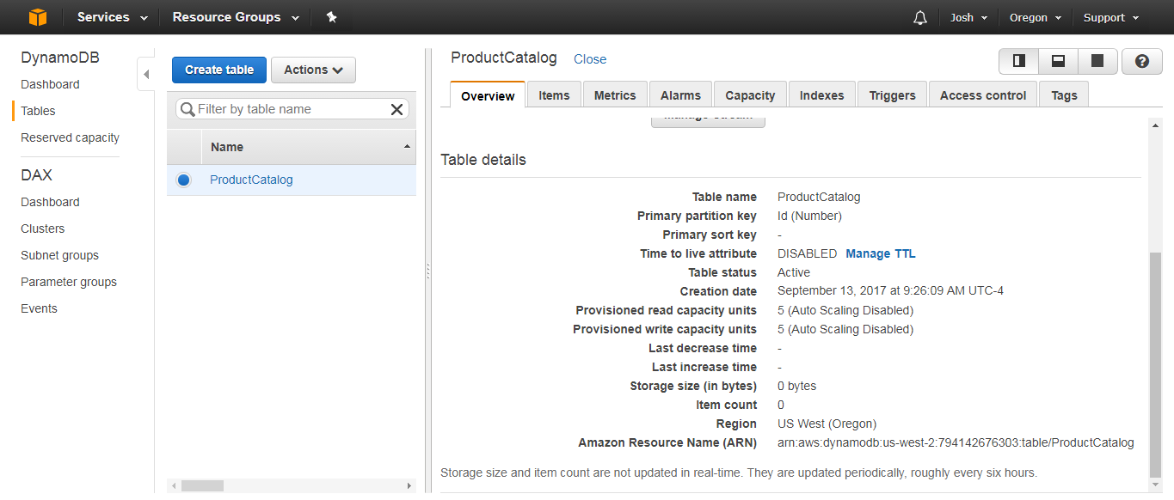

**Create the ProductCatalog Table**

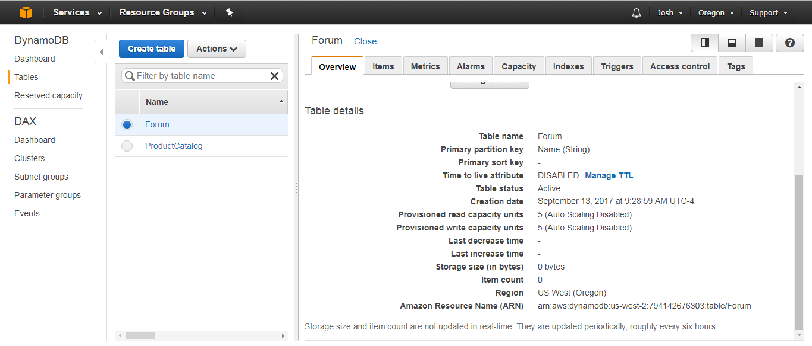

## Create the Forum Table

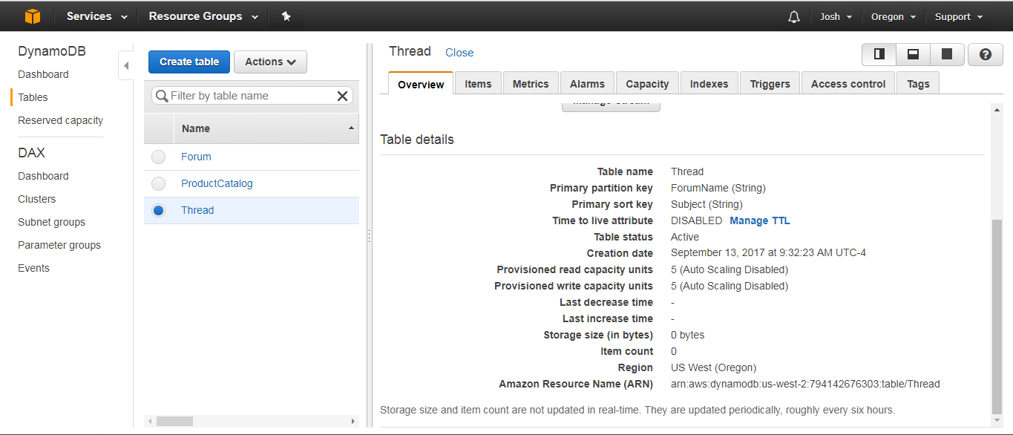

## Create the Thread Table

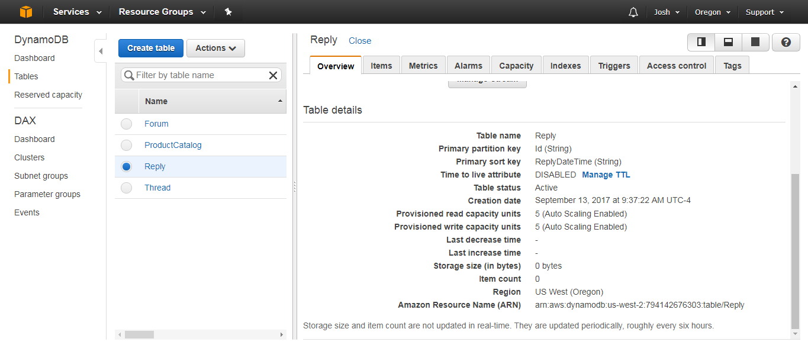

## Create the Reply Table

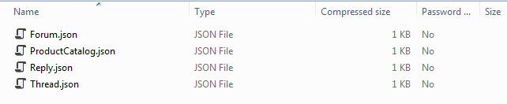

## Download the Sample Data File Archive

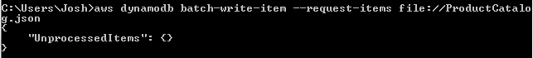

To load the ProductCatalog table with data, enter the following command:



To load the Forum table with data, enter the following command:



To load the Thread table with data, enter the following command:



To load the Reply table with data, enter the following command:

## Load the Sample Data Into DynamoDB Tables

## 

## 

## 

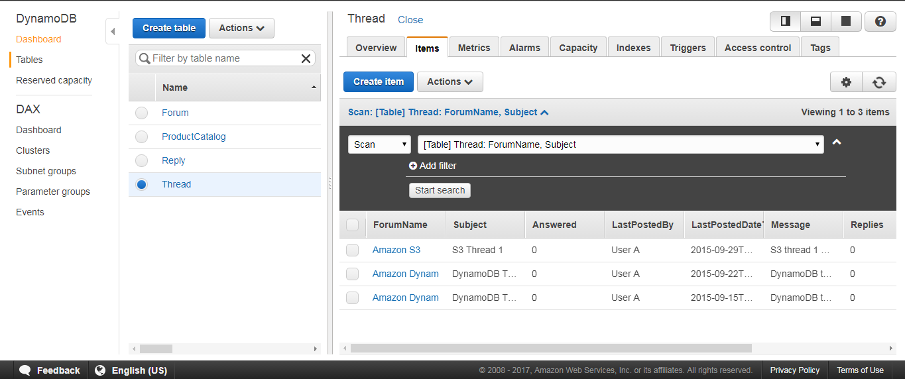

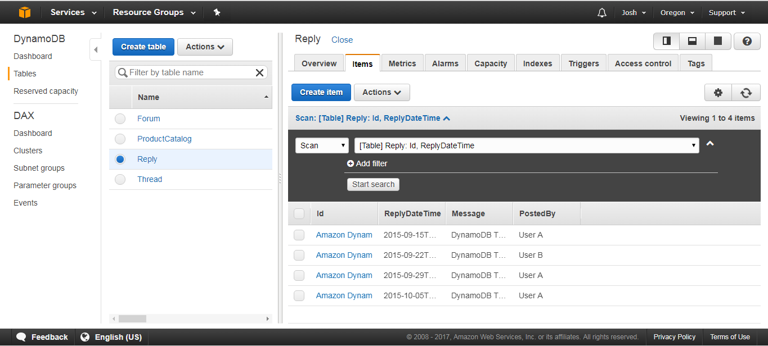

## Verify Data Load